Committee: GA1 – EcoSoc
Issues: How to ensure intelligent use of foreign aid?
What status for frontier workers?
Country: Brazil

The Federative Republic of Brazil, more commonly known as Brazil, is the largest country in South America and the fifth largest country in the world. Brazil's economy outweighs that of all other South American countries and has the 8th highest GDP in the world, however it is still a developing country due to the inequalities within Brazil. Brazil is achieving economic growth through its well-developed agricultural, mining, manufacturing, and service sectors. (fig.1)
Brazil may be solely an emerging donor and developing country, nevertheless, this situation means we have experience as both a donor and receiving country which allows us to have a better understanding of aid. In addition to this, Brazil’s lack of colonial past leads to a political neutrality which is beneficial in the giving of aid which would not be influenced politically. (fig.2) It is also important to note that despite Brazil being a developing country it is a country that gives $1 billion annually in terms of aid.
Foreign aid, although very helpful, is not optimised enough to be able to benefit as much as needed. However the problem is not as most might think the lack of money or donations; it is the way in which these aids are given. The faults in these, if solved would already improve the efficiency of these. (fig.3)
The solutions we propose are very similar to the Paris Declaration of Aid efficiency of February 2004. We are aware that we did not endorse this declaration, as it did not correspond to the positioning of developing countries such as Brazil, but only to the one of traditional donors, nor does it correspond to the particularities of the South-South Cooperation (fig.4). We wish to propose solutions that are adapted to the different abilities of donors.
One issue is tied aid, “mandating that a receiving nation spend on products and expertise originating only from the donor country” (fig.5). The figure shows that is a disadvantage to certain countries’ economies as for example some aid is made to be spent in the United States rather than in developing countries such as Brazil, South Africa or India. Although when used by developed countries it is bad for developing countries, this type of aid encourages the emergence of donors. However it is said to increase the cost of aid by 15-30% (fig.6a). Brazil itself uses tied aid, in reason of being a developing country, and therefore ourselves needing support in order to develop. This is why we suggest that developed countries cease using tied aid and for developing countries to only have fewer than 20% of their aid being tied aid.
Another type of aid that reduces aid efficiency is ‘in-kind aid’ (imported goods), which if replaced by cash aid would be a cheaper, faster and overall more efficient (fig.7). It would also allow aid for the economy of the receiving country as local producers would be the ones giving the much needed goods in exchange for money from the cash aid, therefore improving the efficiency of the aid but also allowing more effective development in the receiving country. This is also better for the donor as they could be achieving more for the same amount of money. Although half of Brazil’s donations are in-kind, a large portion of this is in-kind expertise (fig.2), which isn’t as easily replaced with cash aid.
As previously said, Brazil’s experience as both donor and receiver of aid helps achieve a better understanding of how to harmonise both of these positions. A very important issue, easily solved too, is the fragmentation of aid. This creates unnecessary hassle for the receiver decreasing the effectiveness of the aid they receive. Figure 6b states “there are too many agencies, financing too many small projects, using too many different procedures”, the solution here is quite obvious, all of these need to be reduced, agencies should be merged, several small projects replaced with a few big projects (put in place by both the receiving country and the agencies) and procedures need to be put in place by the UN itself.
A major problem in Brazil is corruption and this problem also occurs within aid due to the transparency of aid meaning that humanitarian aid often does not reach those who are intended to receive it (fig.8). This is problematic for both receiving and donor countries, both which we are. Therefore we would like to make sure aid is recorded in much more detail to prevent such corruption and avoid for our country to give aid and for it to not be used for its purpose, therefore wasting our money, which for a developing country like ours is problematic.
In order to obtain consensus, as this is after all one of the aims of the United Nations, Brazil ensures it will try to decrease its amount of in-kind donations as well as tied aid as to ensure a better use of international aid and ensure the priority is ease for the receiver and not ease for the donor.

Brazil has borders with almost every country in South America other than Chili and Ecuador, nevertheless its experience with frontier workers is almost insignificant compared to certain situations in Europe such as Switzerland. What makes Europe have such a significant amount of cross border workers is mostly the EU as it allows this situation (fig.9) however this clearly does not affect Brazil. We have the Mercosur instead, of course this is not quite the same as the EU, it is on a much smaller scale and was put in place over 30 years later and with countries far less developed than the member of the EU were back in 1958.
Like the EU, the Mercosur promotes free movement of people (as well as trade, goods, currency). The Law of MERCOSUR states that cross border workers are endorsed under certain conditions (necessity of a permit) (fig.10). The ‘Normas Del Mercosur Relativas A Cuestiones Laborales Y De La Seguridad Social’ (fig.11) encourages the States Parties to improve conditions for cross border workers.
We wish for frontier workers to have decent working conditions as well as for their situation to profit their country of residence and their country of labour in order to benefit as much as possible and avoid conflict. This is why we propose that the cross border workers have their employment benefits, workers rights and social security in their country of labour and to pay taxes in their resident country.
We think this would be a good idea as it is beneficial for the economy of both countries, allowing the resident country to collect more tax and the country of labour to have cheaper workforce. We also believe that encouraging cross border workers would help in terms of Brazil’s development and likewise for other developing countries as it could reduce disparities in wealth in our country and increase the amount of middle class citizens. It would also increase attraction in areas other than coastal regions such as Rio de Janeiro or São Paulo.

SOURCES
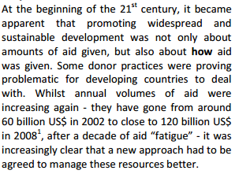
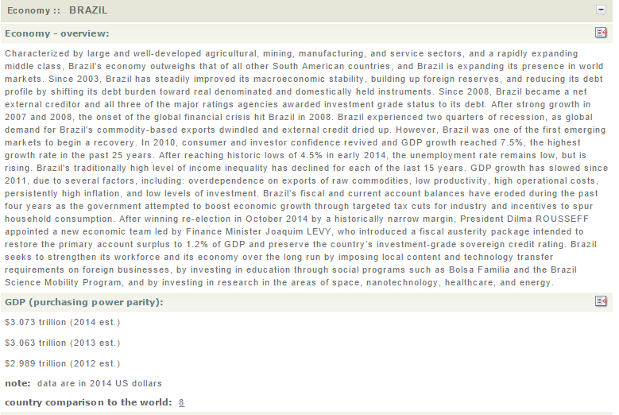

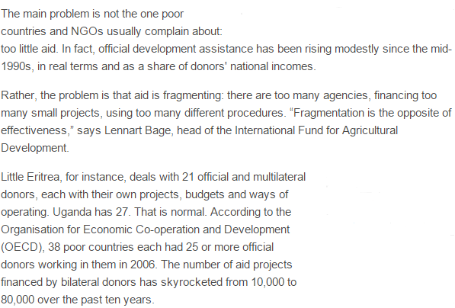

Figure 6 b
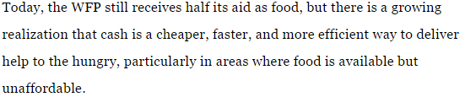

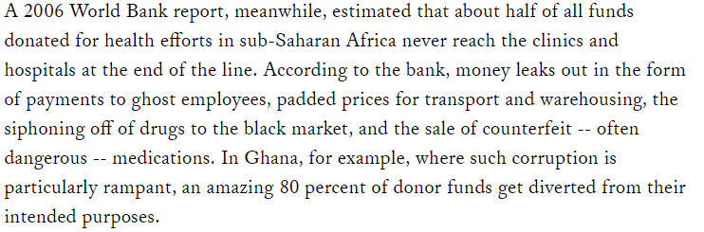
Figure 7: extract CS monitor article - UN aid debate: Give cash, not food? (Jun, 2008)

